**Neha Malhotra**  **R.L. Institute M: 9253556635**

**Max Time : 1 hr** **Class = 12th Biology Test Max Marks : 25**

**Topic : Biotechnology : Principles & Processes**

1. Multiple choice questions : [ 1 X 5 = 5]
2. Agarose extracted from sea weeds is used in :

|  |  |  |  |
| --- | --- | --- | --- |
| a) Spectrophotometry | b) Tissue culture | c) PCR | d) gel electrophoresis |

1. There is a restriction endonucleases called ‘Eco RI’. What does “co” part in it stand for ?

|  |  |  |  |
| --- | --- | --- | --- |
| a) Colon | b) Coelom | c) Coenzyme | d) Coli |

1. While isolation DNA from bacteria, which of the following enzyme is not required :

|  |  |
| --- | --- |
| a) Lysozyme | b) Ribonucleases |
| c) Deoxyribonuclease | d) Protease |

1. Restriction Endonucleases :

|  |  |
| --- | --- |
| a) Synthesizes DNA | b) Cut the DNA molecules randomly |
| c) Cut the DNA molecules at specific site | d) Restrict the synthesis of DNA inside nuclease |

1. The transfer of genetic material from one bacterium to another through the mediation of a viral vector is termed as :

|  |  |  |  |
| --- | --- | --- | --- |
| a) Transduction | b) conjugation | c) Transformation | d) Translation |

1. Name the compound used for staining the isolated DNA in the gel electrophoresis? [ 1 ]
2. How does an alien DNA gain entry into a plant cell by biolistic method? [ 1 ]
3. Write two components of the first artificial recombinant DNA molecule constructed by Cohen and Boyer. [ 1 ]
4. How is DNA is isolated in purified form from a bacterial cell? [ 2 ]
5. (a) Write the scientific name of the source organism if the thermostable DNA polymerase used in PCR. [ 2 ]

(b) State the advantage of using thermostable DNA polymerase.

1. Describe the role of CaCl2 in preparation of competatant cell. [ 2 ]
2. (a) Name the selectable markers in the cloning vector pBR322? Mention the role they play.

(b) Why is the coding sequence of an enzyme B-galactosidase is preferred selectable marker in comparison to the ones named above? [ 3 ]

1. Causative agents of HIV-AIDS and COVID-19 belong to the same group of viruses. To diagnose and amplify the genetic material for further study of Covid -19 virus, RT-PCR test is carried out.
2. What does RT-PCR stands for? [ 3 ]
3. Explain the various steps of PCR technique with the help of diagram.
4. Biorecators are the vessels for production of large scale gene products. [ 4 ]

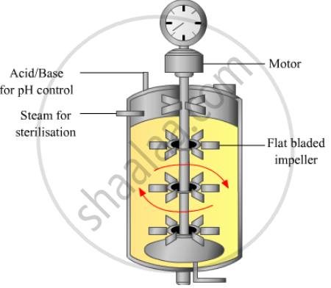

1. How does the development of bioreactors help in biotechnology?
2. What are recombinant proteins?
3. How do bioreactors help in their production?
4. Read the passage and answer the following questions: [ 1 + 1 + 2 + 2 = 6]

Some restriction enzymes breaks a phosphodiester bond on both the DNA strands, such that only one end of each molecule is cut and these ends have a regions of single stranded DNA. BamH1 is one such restriction enzyme which binds at the recognition sequence 5’-GGATCC-3’ and claves

1. What is the objective of this action?
2. Explain how the gene of interest is introduced into a vector.
3. You are given the DNA shown below :

5’ ATTTTGAGGATCCGTAATGTCCT 3’

3’ TAAAACTCCTAGGCATTACAGGA 5’

If the DNA was cut with Bam H1, how many DNA fragments would you expect? Write the sequence of these double stranded DNA fragments with their respective polarity.

1. If a gene M was introduced into E.coli cloning vector pBR322 at BamH1 site. What will be its impact on the recombinant plasmids> Give a possible way by which you could differentiate non-recombinant to recombinant plasmids.
2. Do eukaryotic cells have restriction endonucleases? Justify your answer. [ 1 ]
3. What is gene gun? [ 1 ]
4. What are palindromic sequence ? [ 1 ]
5. How bacteria can be made competent? [ 1 ]
6. Define copy number. [ 1 ]
7. How is insertional inactivation of an enzyme used as a selectable marker to differentiate recombinants from non-recombinants? [ 2 ]
8. Name two commonly used bioreactors. State the importance of using bioreactors : [ 2 ]
9. How can DNA segment separated by gel electrophoresis, be visualized and isolation? [ 2 ]
10. How is the amplification of a gene sample of interest carried out using PCR ? [ 3 ]
11. Draw the figure of vector PBR322 with brief explanation. [ 3 ]
12. Make a chart showing a restriction enzyme, the substrate DNA on which it acts, the site at which it cuts DNA and the product it produces. [ 3 ]